

Securitization Dashboard

Meenakarthika / 29/06/26

1. Project Overview and Objectives
This project focuses on building advanced securitisation risk assessment dashboards and analytics using DAX in Power BI. The primary goal is to transform raw loan-level data (from SAP/ERP systems) into actionable risk intelligence for asset-backed securities (ABS), mortgage-backed securities (MBS), collateralised loan obligations (CLOs), and other structured credit products. The analysis supports credit committees, rating agencies, investors, and regulators by providing comprehensive risk metrics, stress testing, and investor reporting.

2. Key Methodologies and Tools
- DAX in Power BI: Complex DAX expressions are used for weighted averages, stratification, time intelligence, and scenario analysis.
- Data Model: Star schema with dimension tables (e.g., loans, borrowers, vehicles, properties) and fact tables (monthly performance, static pool, dynamic loss).
- Dashboards: Interactive Power BI dashboards with KPI cards, trend charts, roll rate matrices, and compliance indicators.
- Validation: All DAX measures are tested in DAX Studio for correctness and performance (<100ms target).

3. Data Requirements and Risk Metrics

a. Loan-Level Data
- Auto Loan ABS: Loan ID, pool ID, origination details, vehicle and borrower attributes, performance data (delinquency, prepayment, recovery, IFRS 9 stage).
- RMBS: Property type, valuation, occupancy, DSCR, CERSAI registration, title insurance.
- CLOs: Obligor, industry, ratings, leverage, interest coverage, facility type.
- Credit Card ABS: Account-level revolving data, payment rates, utilisation.

b. Pool-Level Metrics
- Weighted Average Coupon (WAC), Maturity (WAM), Loan Age (WALA), LTV, CIBIL Score, DTI.
- Concentration metrics: Top 10 borrower, geographic, originator, vehicle make, HHI index.
- Compliance and trigger tests: Overcollateralisation (OC), Interest Coverage (IC), delinquency and loss triggers.

c. Performance and Loss Analysis
- Delinquency Analysis: DPD buckets (Current, 1-29, 30-59, 60-89, 90+), roll rate matrices, chronic delinquency, cure rates.
- Static Pool (Vintage) Analysis: Cumulative net loss rates by origination cohort, loss timing curves, vintage comparison.
- Dynamic Loss Analysis: Monthly default and loss rates, prepayment speeds (SMM, CPR), recovery rates, excess spread.

4. Regulatory and Rating Agency Requirements
- RBI/SEBI: Minimum Retention Requirement (MRR), Minimum Holding Period (MHP), enhanced disclosure, monthly reporting.
- Rating Agencies (S&P, Moody’s, Fitch, CRISIL, ICRA): Require granular data tapes, pool stratification, loss timing, stress scenario analysis, and compliance with specific models (e.g., S&P LEVELS, Moody’s MILAN).
- ESG Metrics: Environmental (energy efficiency, EV share), social (affordable housing, inclusion), governance (compliance, complaint resolution).

5. Analytical Framework and DAX Examples
- Weighted Average LTV: DIVIDE(SUMX(Loans, Loans[CurrentBalance] * Loans[LTV_Ratio]), SUM(Loans[CurrentBalance]))
- DPD Rate by Bucket: DIVIDE([DPD Balance], CALCULATE([DPD Balance], REMOVEFILTERS(FactLoanPerformance[DPD_Bucket])))
- Roll Rate Calculation: Tracks migration between DPD buckets month-over-month for early warning.
- IFRS 9 ECL: Stage classification, PD/LGD/EAD computation, lifetime vs 12-month ECL.
- Trigger Testing: Automated PASS/FAIL status for OC, IC, delinquency, and loss triggers.

6. Case Studies and Real-World Lessons
- 2008 Global Financial Crisis: Highlighted the need for vintage analysis, roll rate monitoring, and concentration risk reporting.
- IL&FS Crisis (India, 2018): Emphasised obligor concentration, real-time collection monitoring, and regulatory compliance.

7. Best Practices and Recommendations
- Data Quality: Ensure completeness and consistency of loan-level data; use DAX validation and error handling.
- Documentation: Maintain a DAX measure dictionary with business purpose and formulas.
- Automation: Use DAX to automate investor reporting, regulatory compliance, and early-warning alerts.
- Performance: Optimise all DAX measures for speed and accuracy; validate against Excel crosschecks.
- Business Context: Link technical analytics to business impact for stakeholders (investors, regulators, management).

8. Project Deliverables
- Power BI Model: Star schema, DAX measures, 8+ dashboards, RLS implemented.
- Excel Workbooks: ECL crosscheck, waterfall validation, DAX dictionary.
- Presentation: 10 slides summarising key findings and dashboards.
- GitHub Repository: All code, documentation, and models versioned and transferred as per protocol.
Dashboard Implementation
An interactive Power BI dashboard was developed using the provided auto loan securitisation dataset. The dashboard contains KPI cards, portfolio analysis charts, borrower analysis visuals, and interactive slicers to enable dynamic filtering of loan portfolios.

2. KPI Summary

KPI | Description
Total Portfolio Balance | Total outstanding loan balance
Total EAD | Total Exposure at Default
Average Interest Rate | Average interest charged across loans
Average CIBIL Score | Average borrower credit score
Average DTI Ratio | Average debt-to-income ratio
Total Borrowers | Number of borrowers
ECL Provision | Expected Credit Loss

3. Dashboard Features
- KPI Cards
- Clustered Column Charts
- Slicers
- Cross-filtering
- Interactive analysis

4. Business Insights
- Most loans belong to IFRS Stage 1.
- Borrowers with higher DPD buckets show increased portfolio risk.
- Higher CIBIL scores generally indicate lower default risk.
- Interactive slicers allow portfolio analysis by employment type, vehicle type, and insurance type.

5. Dash Board
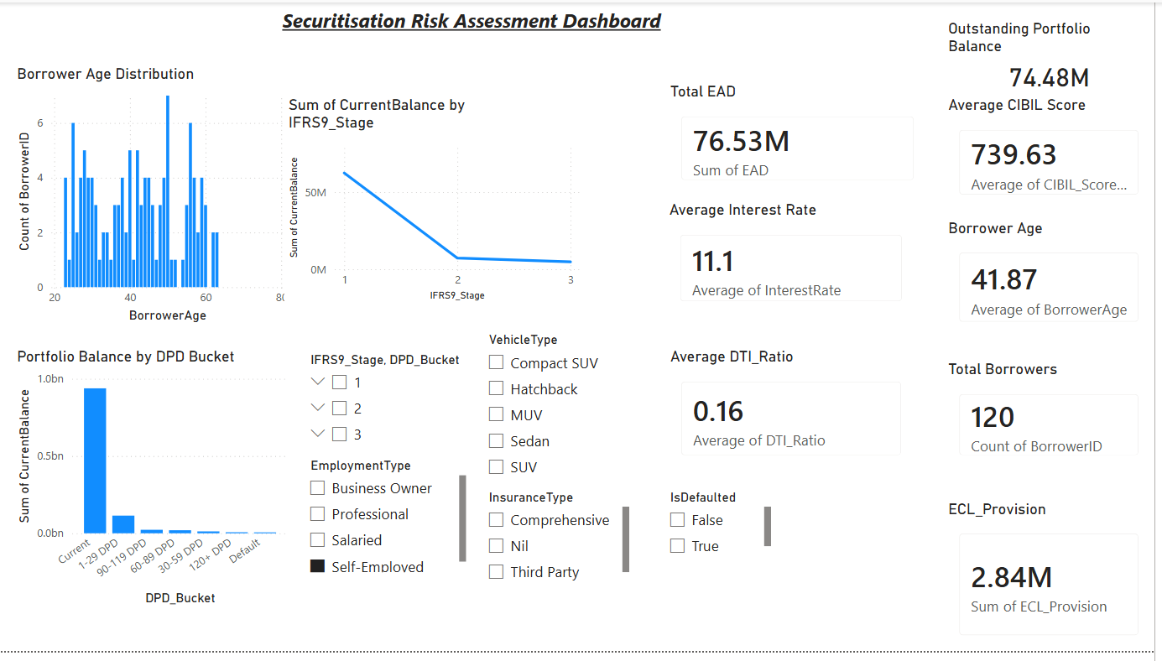

IFRS Stage Chart
